LAYOUT OF WEBSITE :

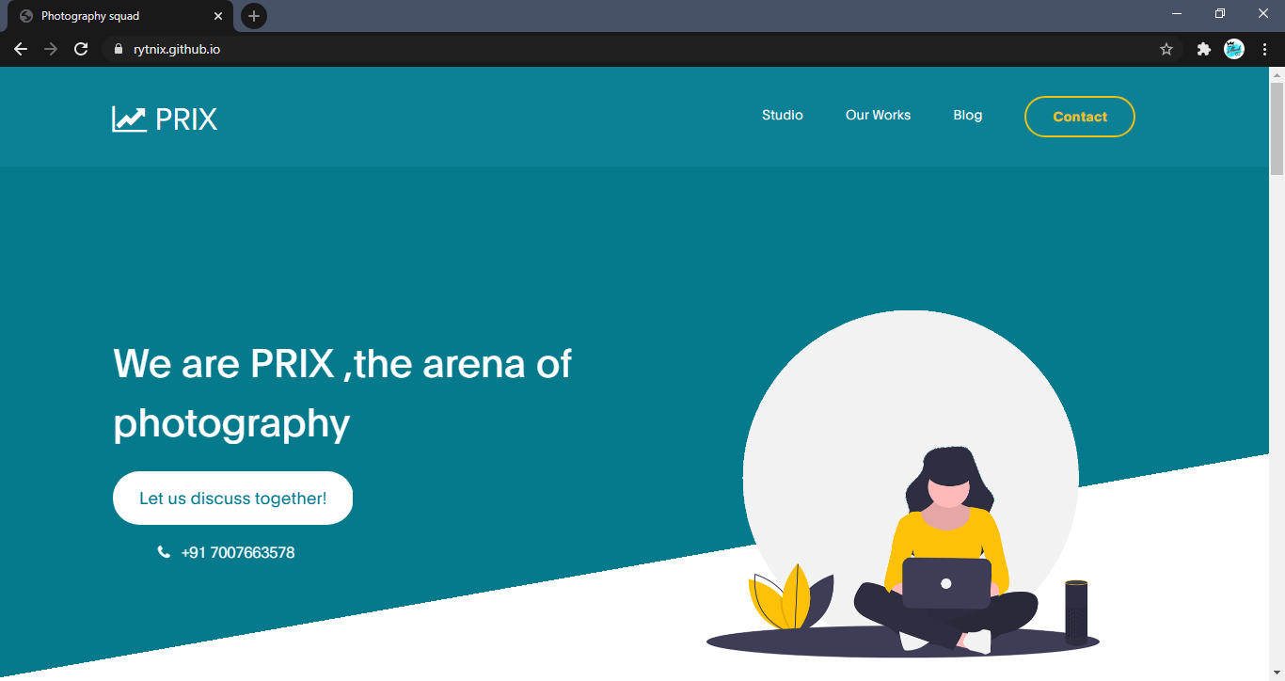

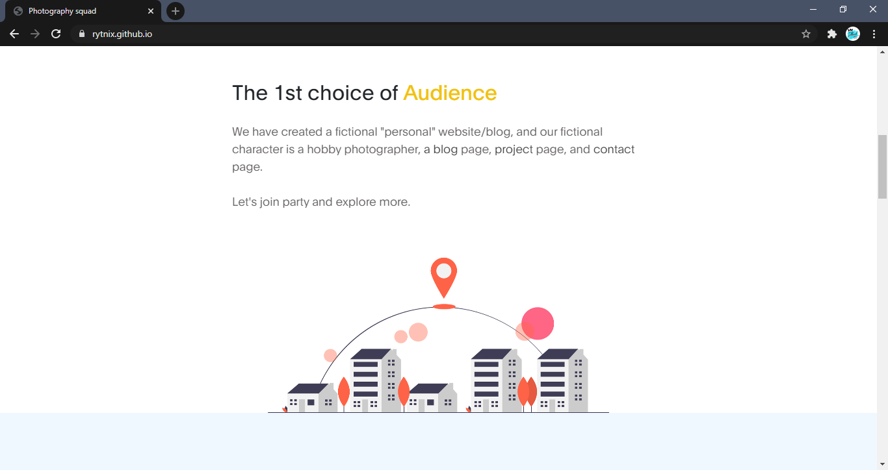
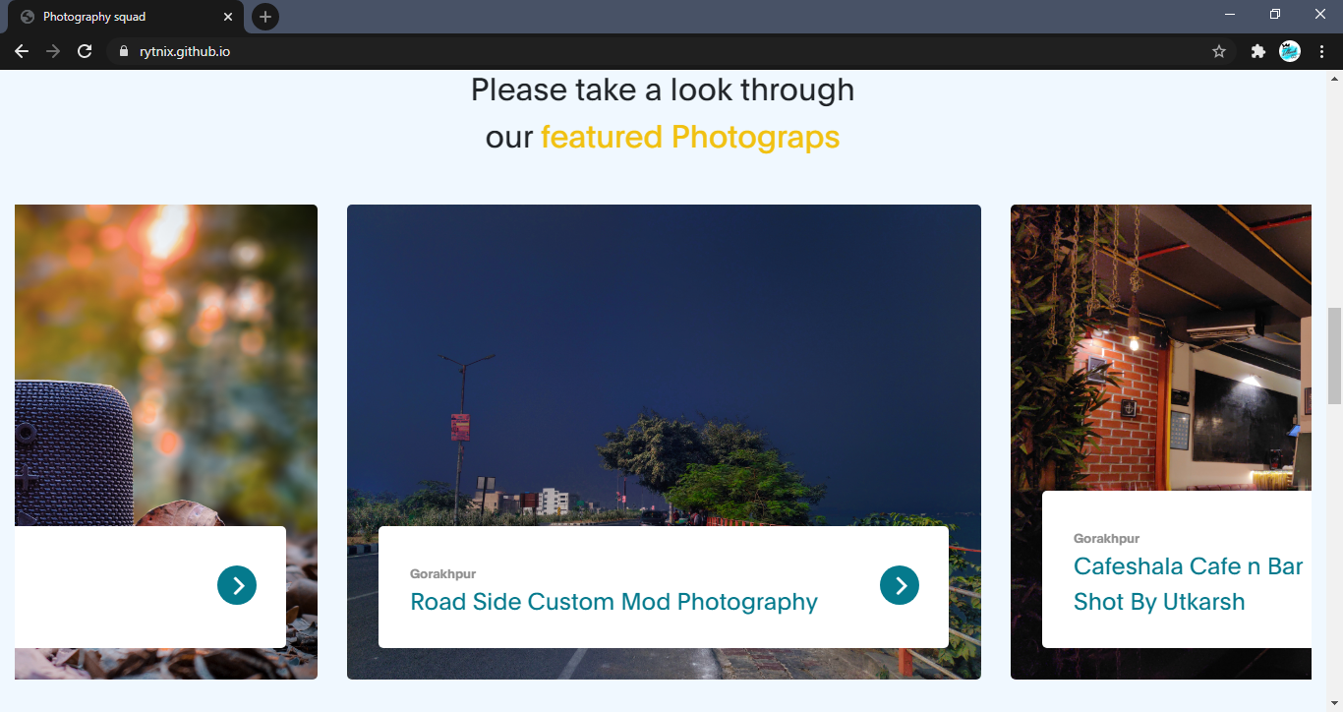

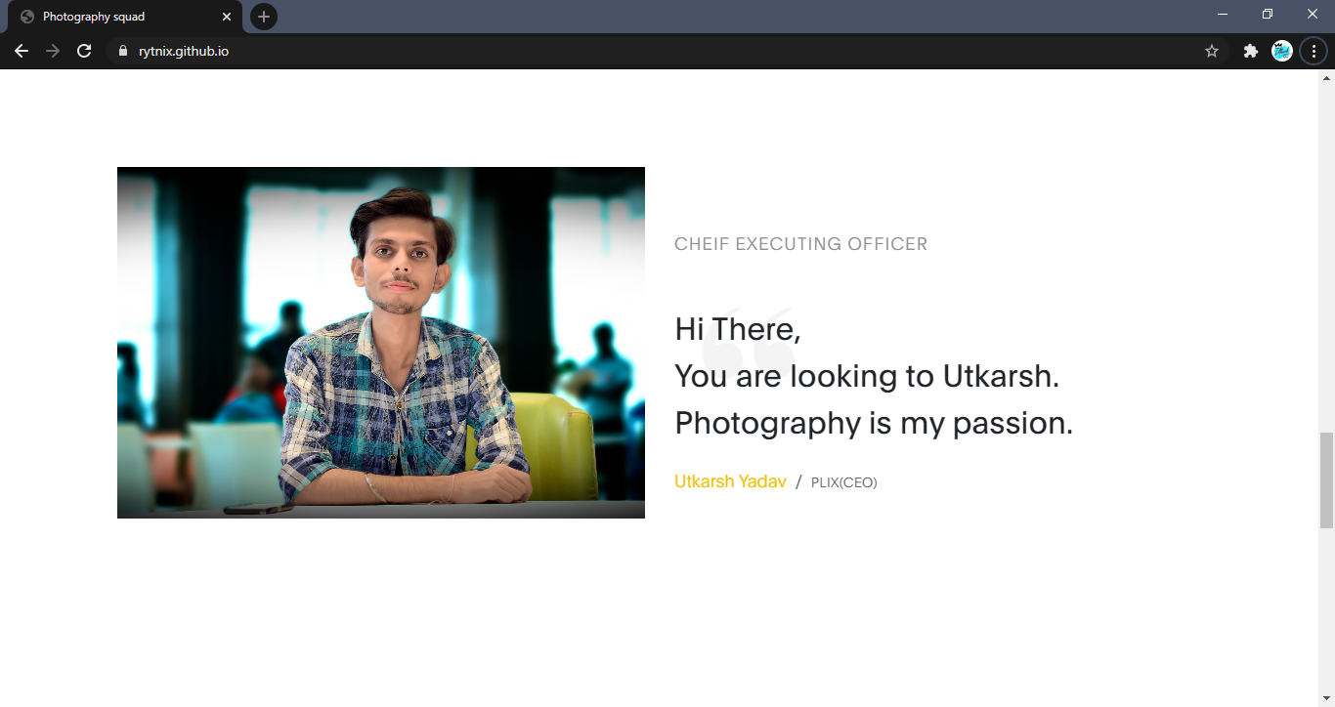

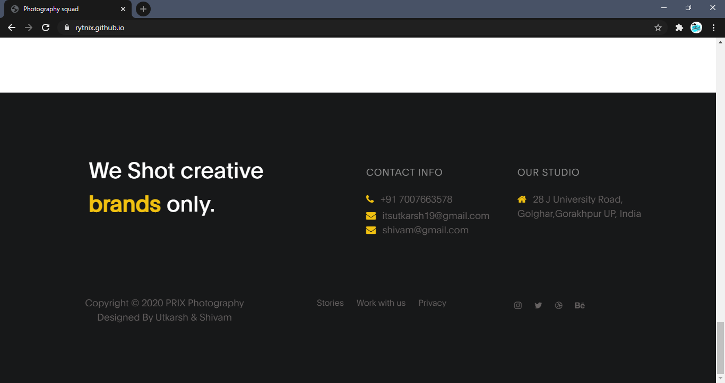

BUILD BY :

UTKARSH YADAV
&
SHIVAM YADAV

SUBMITTED TO SUBMITTED BY
RAVIKANT SIR UTKARSH & SHIVAM

